 | Class Teacher:  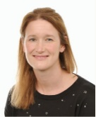  Mrs Dunstone |  |  | 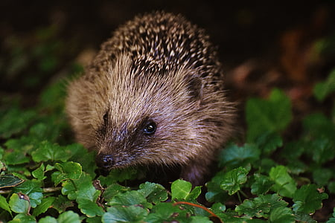  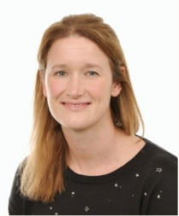 |  |  | Learning Support Assistant/PPA Cover  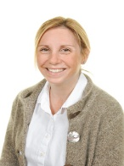  Mrs Ely
Learning Themes | Terms 1 & 2: The Magic of Me in My World |  | Term 3 & 4: Wonder and Wander |  |  |  |  | Term 5 & 6: Wonderful, Wild, World!
  School Routine:  The school day starts at 8.45am which is when the register is taken. Children are welcome into the classroom from 8.35am. We encourage them to come into the classroom independently and organise their belongings.  Your child will need to bring a bottle of water each day. Free milk is available for children until they turn 5 years old. If you want your child to continue having milk after their fifth birthday, please contact the school office. Free Fruit is available daily until the end of year 2 but children may prefer to bring in their own fruit or healthy snack.  Please collect your child from the playground doors at the end of the school day. If there is a different person picking up your child, please contact the school office or let a member staff know. The school day finishes at 3.15pm. |  |  |  |  | 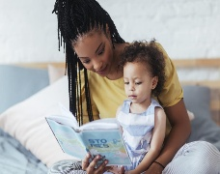  Reading:  In Hedgehog Class we will share lots of stories and explore non-fiction. We will complete weekly reading sessions which supports the skills of decoding and interpreting different texts.  We will hear your child read as frequently as possible and there will be a timetabled reading time each day to help to encourage and embed reading for pleasure. We have a cosy book corner where the children can relax with a book and a library where children can select a book of interest to borrow.  Please share a book with your child at least 5 times each week and record this in their reading record. Reading records will be collected in and checked every Friday and Class Dojo points will be awarded for every shared read. On their reading day, children will also be allocated a new hard copy of their banded reading book for the week. Please encourage your children to re-read this book for fluency and to develop their comprehension skills. |  |  |  | Learning at Home:  home learning is as follows:  - Read at least 5 times a week  - Practise phonics cards and words when issued.  - Numbots/White Rose Maths  An additional sheet with optional project home learning will also be sent out for each topic. This will consist of activities to do linked with the term’s project; they can do as many or little as they like and bring in their work to share with the class. We will usually share each Friday.
Forest School:  In Term 6, Hedgehog class will be participating in Forest School with Mrs Dawes. A medical questionnaire and permission letter will be sent home to be completed and returned. A kit list will also be sent home as appropriate clothing will be necessary. |  | Physical Education:  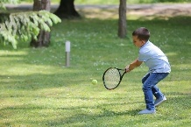  Children need to change into their PE kit at school on PE days. Please ensure that their kit is always in school and kept on their peg. Long hair will need to be tied back and be aware that jewellery will need to be removed. Games sessions will be outdoors, as much as possible, so please make sure that your child has tracksuit bottoms and a navy-blue sweatshirt or school ‘hoody’ to wear. For Term 1 & 2 PE lessons will be on a Tuesday and Friday. During Term 6 Forest School will be in place of one PE lesson. |  |  |  | Communication:  Letters will be sent home via Arbour or given to children at the end of the day. Notices and information about weekly events will be posted on Class Dojo or Arbour. We will also be using Class Dojo to share learning and events that happen during the school week. The school newsletter will detail upcoming events for the term – this will also be sent via Arbour. If you wish to speak to us, please let us know at the beginning or end of the school day or message on Class Dojo. Alternatively contact the school office who will pass your message on to us.

